**Student Instructions**

Name:__________________________

Get proper title

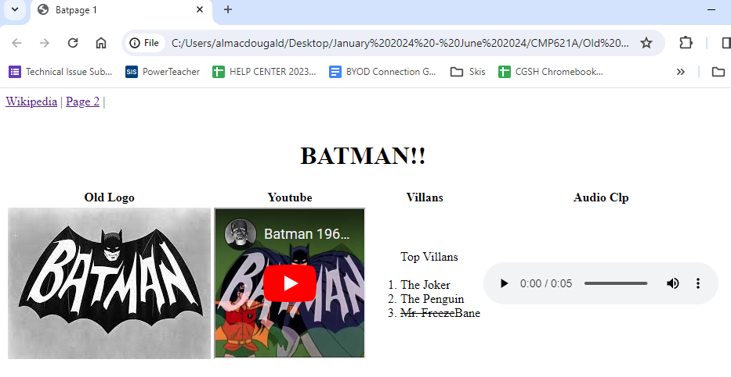

Items in list are numbered automatically.

Table headers for this row.

Takes to page 2, no new tab.

Takes to wiki in a new tab.

Plays the audio clip that says “Tomorrow, same bat time, same bat channel!”

Plays the Youtube video, the address is correct in the given HTML document. The width and height are 190.

Clicks on image and the link will take you to page 2. No new tab.